**ICE 12**

id:7   
name: Harshil Patel

wiki link: <https://github.com/Harshilpatel134/IOT/wiki/ICE-12>

[Document](https://github.com/Harshilpatel134/IOT/tree/master/ICE/module2/ICE6/document)   
[Scource](https://github.com/Harshilpatel134/IOT/tree/master/ICE/module2/ICE6/scource)   
[video](https://www.youtube.com/watch?v=Kes51zMyM00)

**objective**

for this in class we are working with NAO robot

1. performe basic task.
2. communicate with NAO.
3. use rest API to get weather data using NAO robot.

**Approaches**

1. Construct flow for NOA.
2. Write python code to interact with NOA (use REST API call the get weather data from web service).
3. Add python code as module for NOA.

**flow diagram**

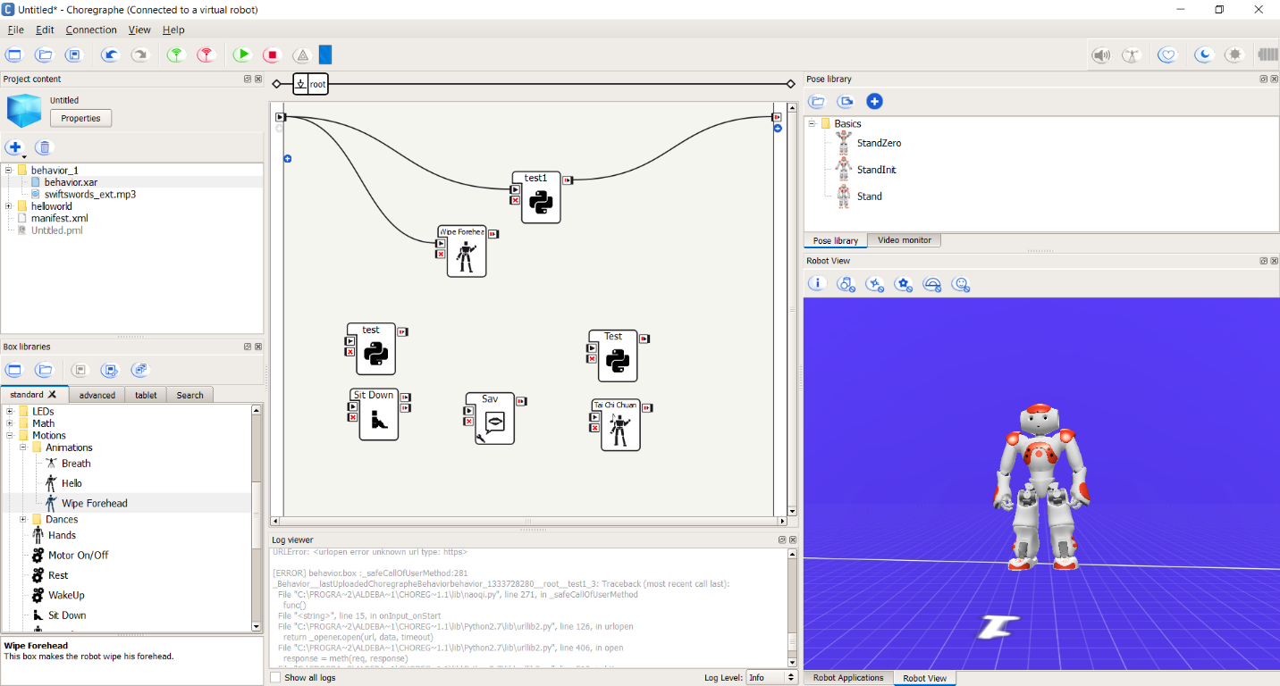

**code**

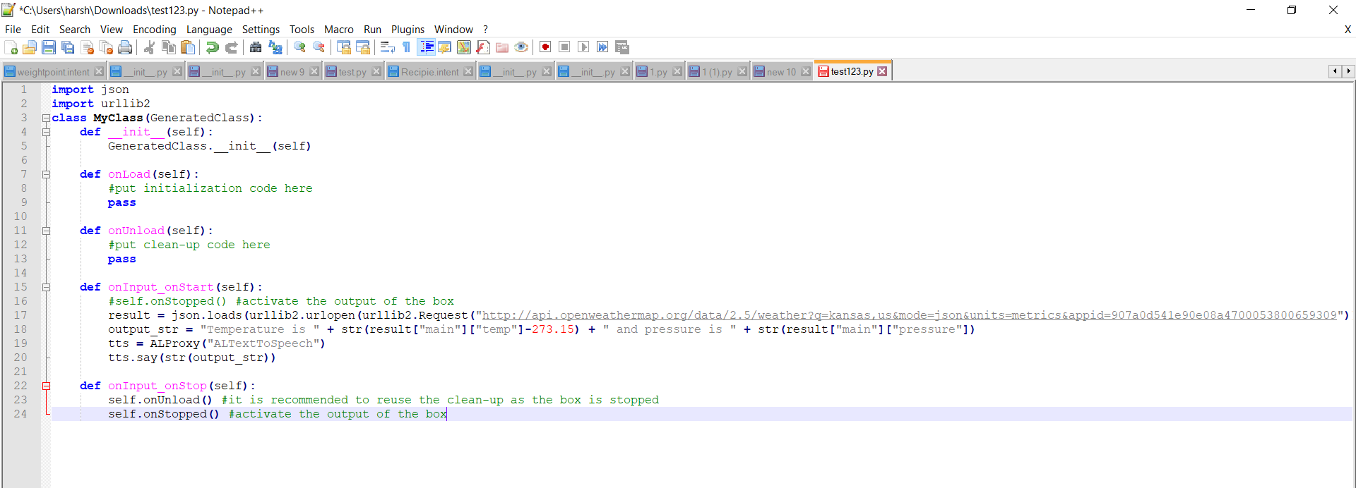

**conclusion**

with the help of this assignment we where able to learn...

1. how to performe basic task with NAO.
2. communicate with NAO.
3. using rest API to get weather data using NAO robot.